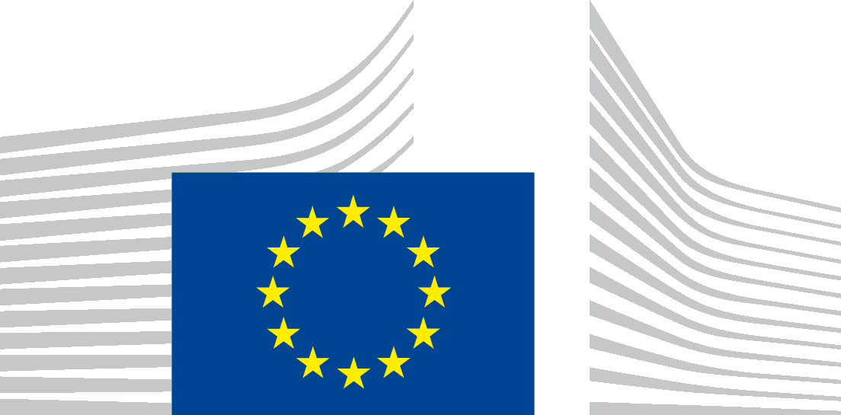 | EUROPEAN COMMISSION  DG JOINT RESEARCH CENTRE  Directorate G – Nuclear Safety & Security  Unit G.I.4 – Nuclear Reactor Safety & Emergency Preparedness

Registration Form
European Commission funded International Workshop
Materials resistant to extreme conditions for future energy systems
June 12-14, 2017
Kyiv, Ukraine

Please return this form before May 1st, 2017 to:
JRC-PTT-ENLARGEMENT-WORKSHOP-KYIV-2017@ec.europa.eu

Family name:
First name:
Affiliation:
Position:
Nationality:

Postal Code, City:
Country:
Nationality:

Telephone:
Email:

Workshop Attendance
I will attend June 12 June 13 June 14
Please indicate if you have any nutritional request (vegetarian, allergy…)

Have you submitted an Abstract? YES NO
If yes a poster YES NO
Or an oral presentation YES NO

Social Event
Do you intend to attend a social event the 12th of June YES/opera YES/walk in Kiev NO
Do you intend to attend the Workshop dinner 13th of June YES NO

Post-Workshop events
Will you join the Chernobyl tour the 15^{th*} YES NO
Will you join the H2020 training the 14th YES NO

* in this case you will need to fill in the special form for the Chernobyl visit (to be provided)

