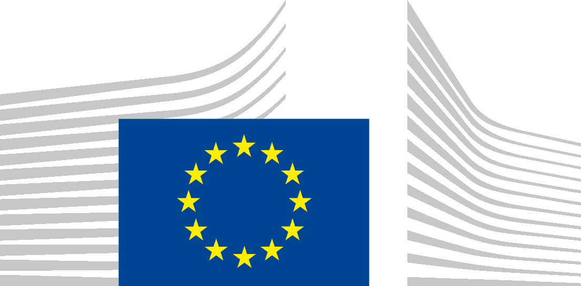 | EUROPEAN COMMISSION  DG JOINT RESEARCH CENTRE  Directorate G – Nuclear Safety & Security  Unit G.I.4 – Nuclear Reactor Safety & Emergency Preparedness

Application form Abstract & Grant

European Commission funded International Workshop

Materials resistant to extreme conditions for future energy systems

June 12-14, 2017
Kyiv, Ukraine

Please return this form before March 25, 2017 to:
JRC-PTT-ENLARGEMENT-WORKSHOP-KYIV-2017@ec.europa.eu

Family name:
First name:
Affiliation:
Position:
Nationality:

Postal Code, City:
Country:
Nationality:

Telephone:
Email:

Abstract for oral presentation/Poster
Do you have an Abstract YES NO
It yes, oral or Poster presentation Oral Poster

If, yes
- Indicate which Technical sessions: ‗‗‗‗‗‗‗‗‗‗‗‗‗‗‗‗
- please attach a one-page Abstract (see template)

Target Country
Are you from a target country*: YES NO
Do you apply for a European Commission grant?: YES NO

* citizen of a target country or working in a target county

